Name : Pranjal Hedau PRN : 25070521172
2.1.1 Roots of Quadratic Equation
ALGORITHM
- Start
- Import the math library.
- Read three integers a, b, and c (coefficients of the quadratic equation).
- Calculate the discriminant
$D=b^{2}-4ac$
5. If D > 0:
Calculate two real and different roots using:
$\frac{-b+\sqrt{D}}{2a},\frac{-b-\sqrt{D}}{2a}$
Print both roots up to 2 decimal places.
- Else if D == 0:
Calculate the single repeated root:
$$\frac{-b}{2a}$$
Print the root twice up to 2 decimal places.
- Else (D < 0):
Calculate real part:
$$\frac{-b}{2a}$$
Calculate imaginary part:
$$\frac{\sqrt{-D}}{2a}$$
Print both complex roots up to 2 decimal places.
- Stop

FLOWCHART
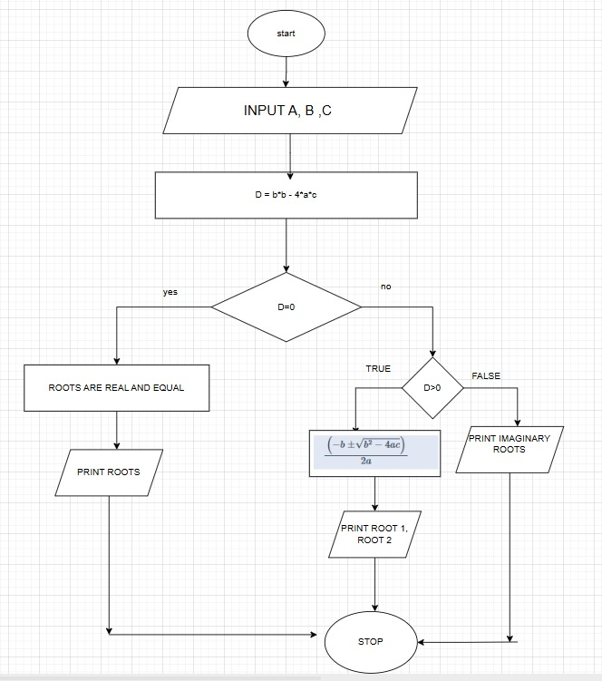

PHYTHON CODE
import math

a, b, c = map(int, input().split())

D = b*b - 4*a*c

if D > 0:
root1 = (-b + math.sqrt(D)) / (2*a)
root2 = (-b - math.sqrt(D)) / (2*a)
print(f"root1 = {root1:.2f}")
print(f"root2 = {root2:.2f}")

elif D == 0:
root = (-b) / (2*a)
print(f"root1 = root2 = {root:.2f}")

else:
real = (-b) / (2*a)
imag = math.sqrt(-D) / (2*a)
print(f"root1 = {real:.2f}+{imag:.2f}i")
print(f"root2 = {real:.2f}-{imag:.2f}i")

EXCECUTION
